**STORING THE CHAT HISTORY IN FILE AND LOAD**

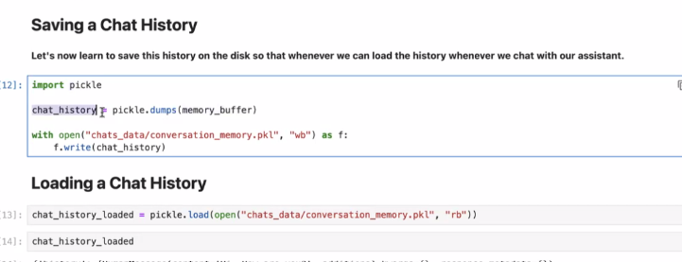

**STORING CHAR IN DB**

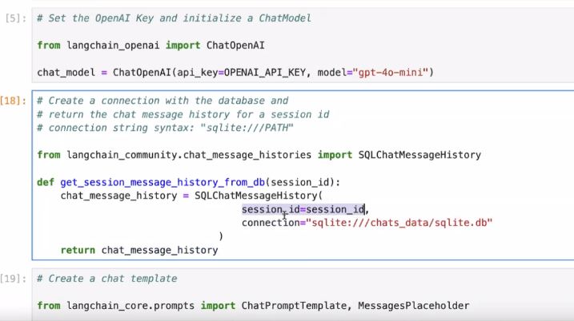

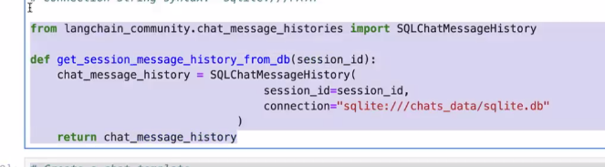

The below runnable history connect the db and reterives the previous chat, and from chat template is takes the human and chat history that users type now

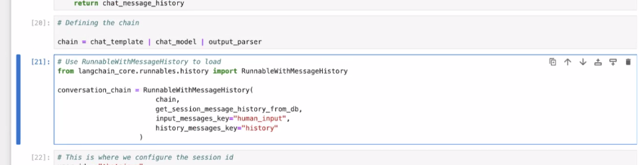

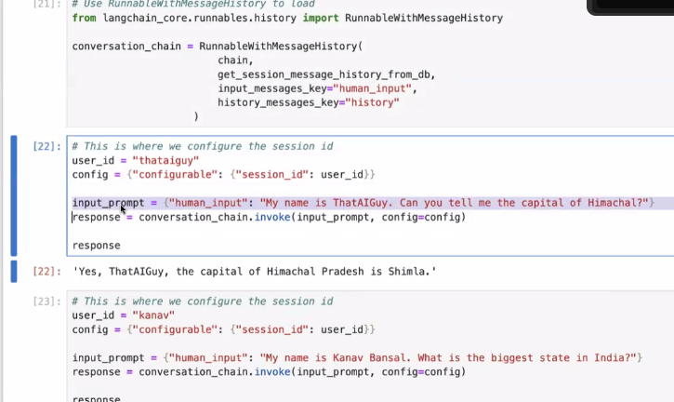

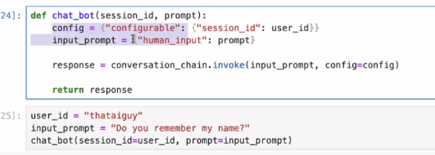

**CONNECTING MONGO DB**



**LANG GRAPH MEMORY FOR STORE CHAT HISTORY (RECOMMENDED ONE)**

